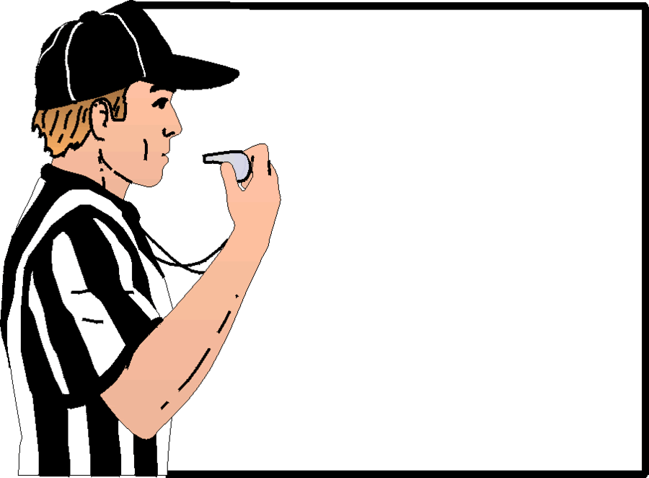
"10 TIMES OUT ! ! "

Please join us in Celebrating the
10 Year Reunion for
Brother Thomas R. Mason, PGP

Saturday, July 26th, 2025

Core Event Center
100 Colony Drive
Irwin, PA 15642

Receiving Line/Doors Open at 11:00 a.m.
Luncheon at 11:30 a.m.
(Casual Business Attire - Capri's Ok / No Jeans)

Reservations Due by July 9th, 2025
(May be limited seating.)

COST - $35.00

Hosted by Club Board, Sessions,
and Grand Officers of 2015 - 2016

"Remembering Sister Mary H. Stillman, PGM"


*********************************************************************************************
"10 TIMES OUT" - - - - -Ten Year Reunion for Thomas R. Mason, PGP

Name:_______________________________________________________________________________________

Title:________________________________________________________________________________________

Chapter Name & Number:___________________________________________ Region:_____________________

Guest Name / Title:_____________________________________________________________________________

Phone #:________________________Special Dietary Restrictions:_______________________________________

CHOOSE ONE MEAL: Homemade Gnocchi w/Meatballs _______ MAIL TO: Maxine Bateman, PM
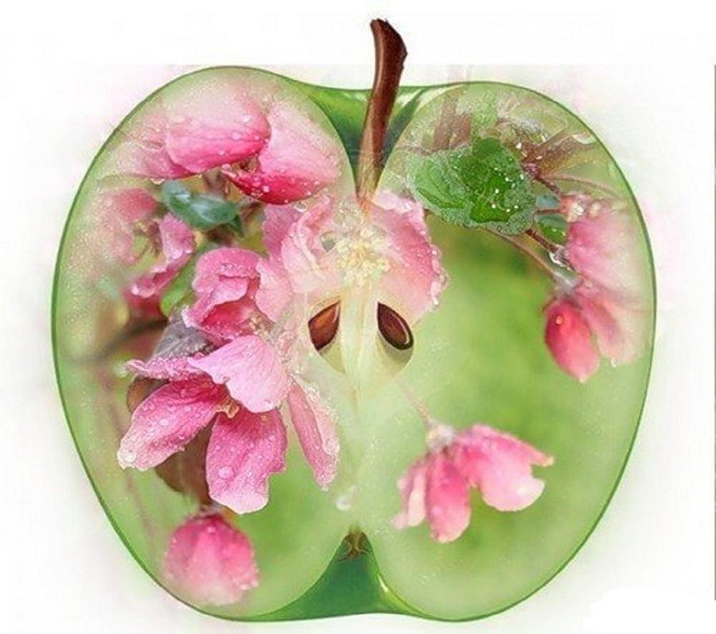
Chicken Romano over Pasta ___________ 514 Sarnese Drive
Baked Cod in Lemon Butter ___________ Derry, PA 15627
mrsbatman104@aol.com 724-454-4152

TOTAL RESERVATIONS _______ ENCLOSED $ __________ (Checks made to Maxine Bateman)

